PecWFDisplay
1. Drag the object from Analogs to Axis.
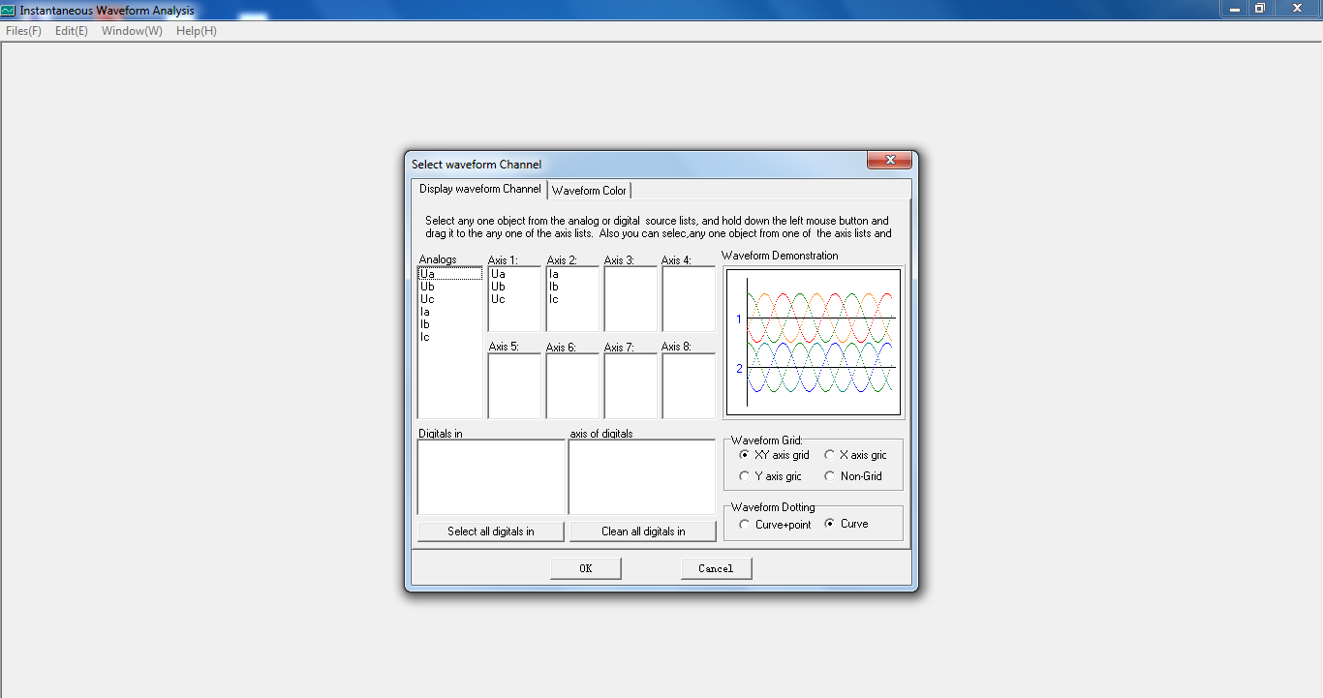
2. Select the axis: Click the or axis icon from the toolbar on the left.
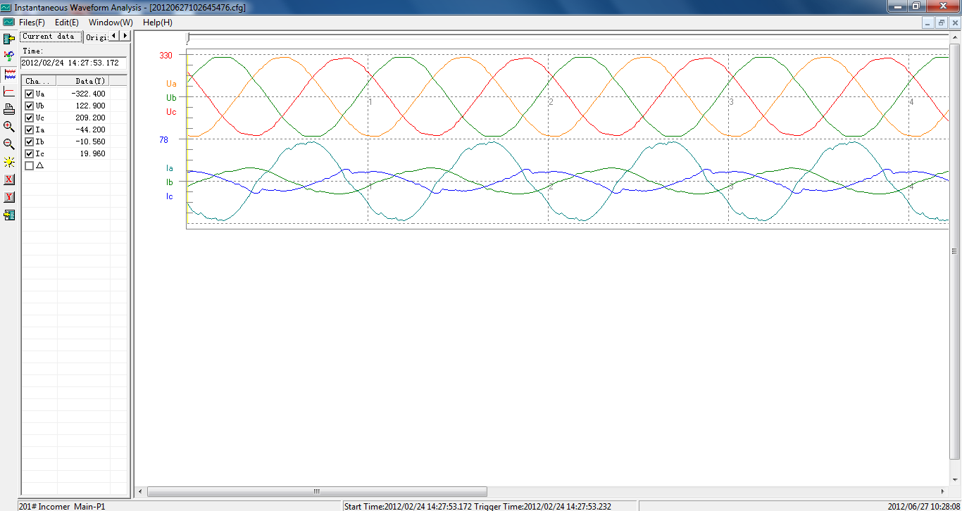

3. Click the or icon, then the waveform will be zoomed in or out. Click the zoom icon repeatly to continue to double zoom.
